Following are a series of figures and diagrams that illustrate the drying installation. Please refer to the text in the body of this manual for a full description of these figures and diagrams.

    - Figure — Photograph of Appliance
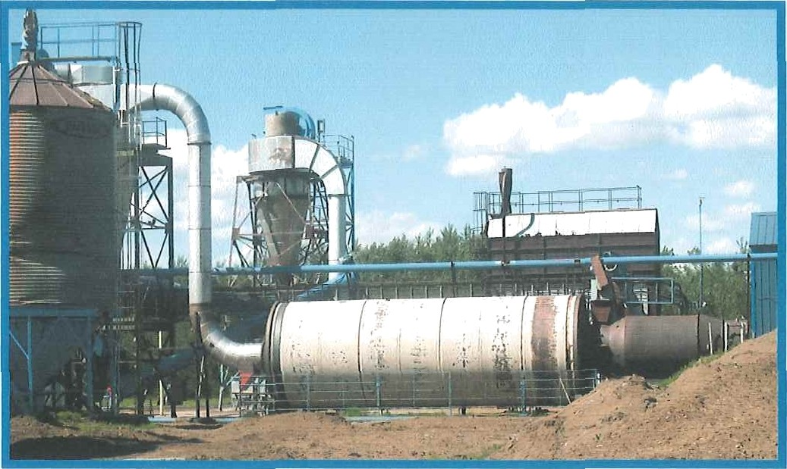

    - Figure - Schematic of Appliance and Airflow

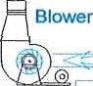

    - Figure — Fuel Train Installation

View: Fuel Train Installation (view from north)
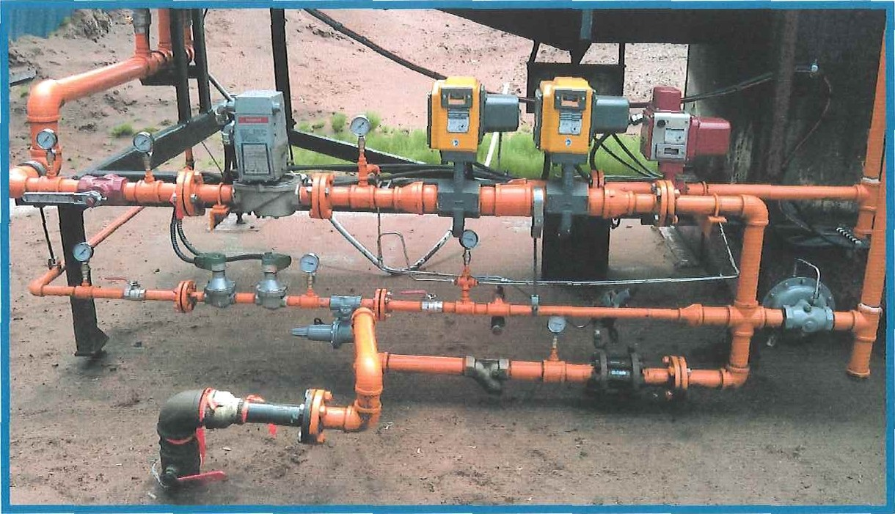

View: Fuel Train Installation (view from northeast)
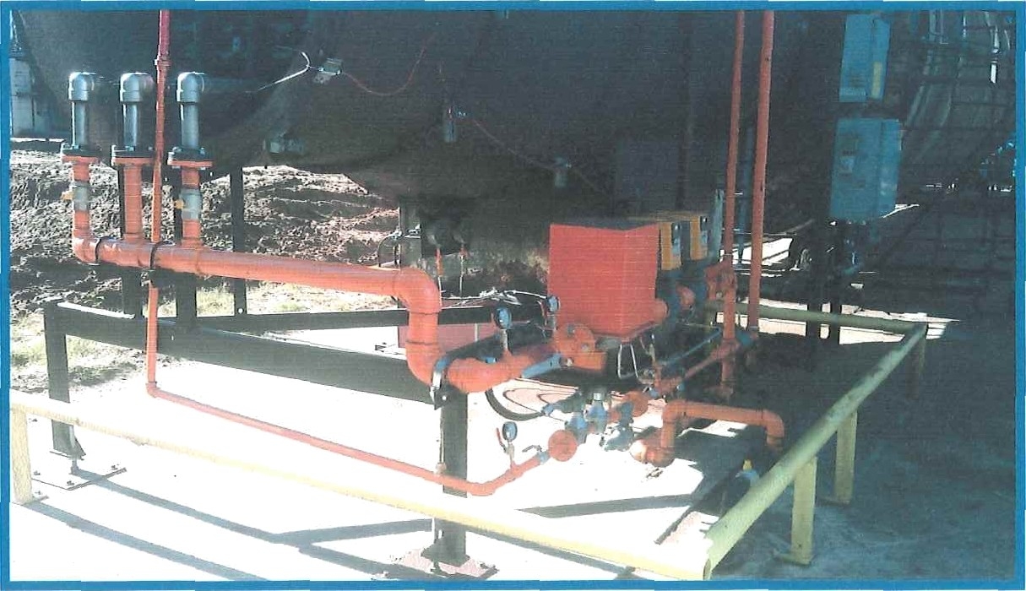

Fuel Train Component Rating Plates
The rating plate situated on each fuel train component is not to be defaced or removed from the component.

    - Electrical Approval Label
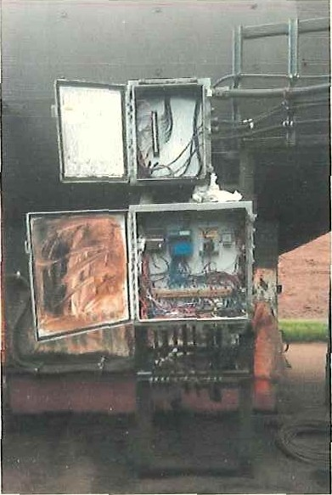
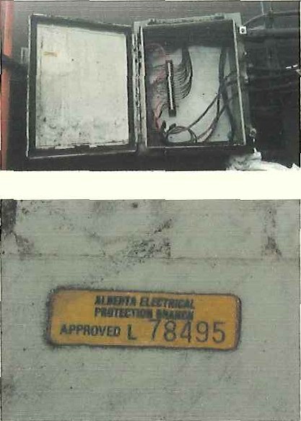
Location: Electrical cabinet above the Flame Control Panel.

Appliance Certification Label
The Appliance Certification Label that indicates that the appliance is certified by special inspection to conform to CSA B149.3-10.

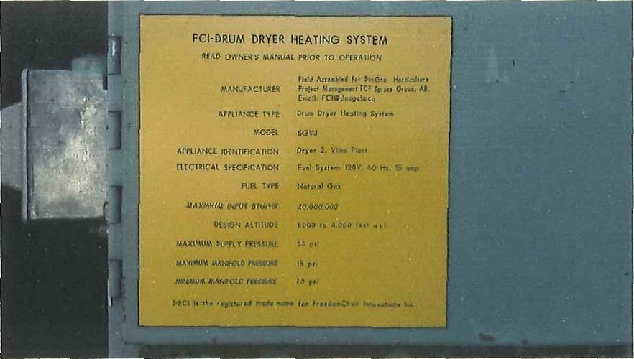

  - Required Training and Information Updating
All operators and maintenance personnel are to be adequately trained prior to operation or maintenance of the burner equipment on this dryer.

Information beyond the contents of this Owner's Manual is required for the safe operation and maintenance of the burner system on this dryer. This additional information includes but is not limited to:
    - plant emergency procedures,
    - “lock out” procedures,
    - hot work procedures,
    - confined space entry procedures,
    - PPE Personal Protection Equipment requirements,
    - and operation and maintenance pi'ocedures related to the materials handling equipment associated with this dryer burner system.
This information is available in plant information sheets and manuals not included in this Owner's Manual.

This Owner's Manual and included "Safety and Operational Checklists" are to be updated if there are changes to plant operating and maintenance procedures that impact on the safe operation or maintenance of this flame control system.

  - Equipment Start-Up Interlocks
The conveying equipment, drying drum, dryer blower and dryer flame control system are interlocked such that they can only be started in a specific order. The conveying equipment must be engaged before the drum can be started, the drum before the blower and so on.

The dryer flame control system is the last item in the interlock sequence to be energized. The plant materials handling equipment must be energized before the burner will ignite (ligbt K
The burner will ignite (light off) with the temperature control operating in the “manual” mode.

  - Prior To Dryer Opel ation
    - Assure Emergency Preparedness
      - Confirm the required emergency preparedness is in place according to plant operating procedures, which include but are not limited to:
        - Emergency response procedures,
        - Firefighting equipment and water supply,
        - Buddy-Up requirements, etc.

Coordinate Drying Activities
      - Confirm the drying parameters to be applied, which include but are not limited to:
        - Type of drying to be conducted;
        - Condition of dryer input product,
        - Intended operating temperatures,
        - Destination of dryer output product,
        - Preparedness of dryer output destination (example truck in place)
      - Assure all personnel in the vicinity of equipment to be operated are aware of the intended activity.
      - Assure that all equipment associated with the dryer are ready for safe operation in accordance with plant operating procedures.

Assure Personnel Are Adequately Trained and Equipped
      - Assure all personnel operating or in the vicinity of the equipment are appropriately trained and equipped with appropriate PPE as prescribed in the plant operating instructions.

Clear Equipment Of Pemonnel And Foreign Objects
      - Assui'e all personnel are safely clear of burner and equipment to be operated.
      - If recent maintenance or inspections were conducted, assure that lockouts, loose wrenches or parts, access panels and all foreign objects are removed or made safe for dryer operation.

’ ’’ ’ ‘‘

Open ñfasfer Gas Stipp/y Ve/v'e At Gae Shack
      - When opening the master gas valve, firstly crack the valYe open slightly to allow the supply line to fill gradually. The sound of moving gas will end when the line is filled.
      - Open the master gas valve fully after the line is filled.
      - The valve is open when the handle is in line with the gas line.

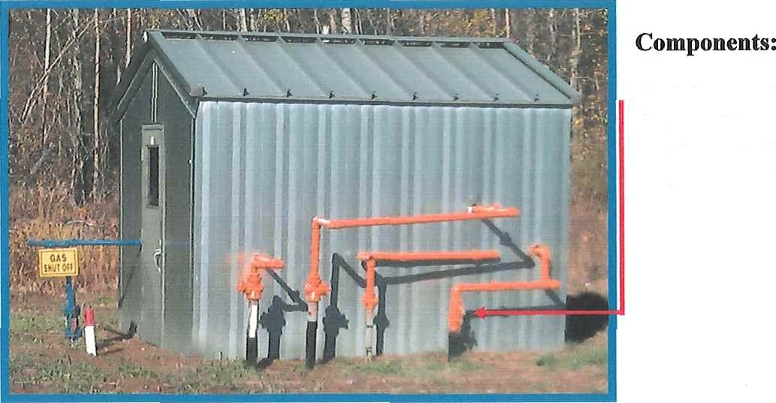
View: Master Valve at Gas Shack

a) Master valve “crack open” to gently fill the underground line to the dryer

    - Open App/iance Gas V'alve
      - When opening the Appliance Chas Valve, firstly crack the valve open slightly to allow the Fuel Train to fill gradually. The pressure gauge will indicate when the line is filled.
      - Open the Appliance Gas Valve when the line is filled.

View: Appliance Valve

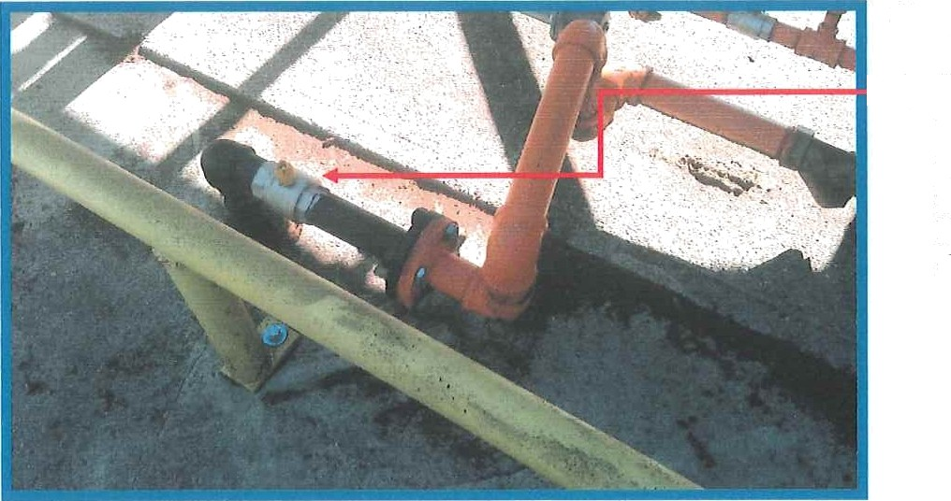
Components:

a) Appliance valve “crack open” to gently fi11 the line to the dryer

    - Open Manual Firing Valves
      - Fully open the main burner Manual Firing Valve.
      - Fully open the pilot burner Manual Firing Valve.

View: Manual Firing Valve

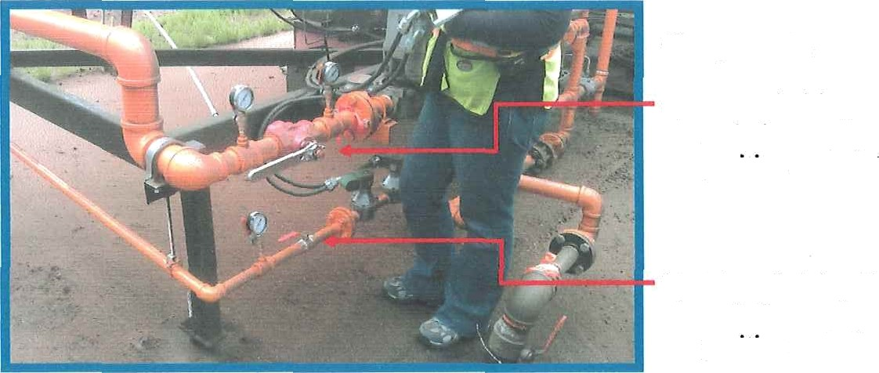
Components:

- Manual Firing Valve, main burner, open position

- Manual Firing Valve, main burner, open position

Warning:
The handle of the Manual Firing Valve is not to be removed and must be in place prior to burner operation.

    - Engage Product Conveyors, Drum and Fan
      - The plant conducts 2 different types of drying and transports dried product fiom the dryer to several destinations.
      - Prior to initiating the flame in the drum dryer, the safety interlocks with other plant equipment must be satisfied. The plant conveyors, dryer drum, and dryer fan must be started and/or set before the flame control system will be electrically energized to permit ignition (light off) of the bumel.
      - Refer to plant equipment operation procedures for the safe engagement of this related equipment.

    - Confirm Fuel Control Relay and Airflow Sensor Energized
      - The plant equipment incorporates numerous electrical circuit interlocks. After the required plant equipment required to support the dryer are engaged, the plant operating procedures energize the fuel system management relay and then the proof of combustion air circuit.
      - Ensure the four (4) indicators on the Control Tower Fuel Control System Panel indicate the circuits are energized.

View: Tower fuel system management indicators

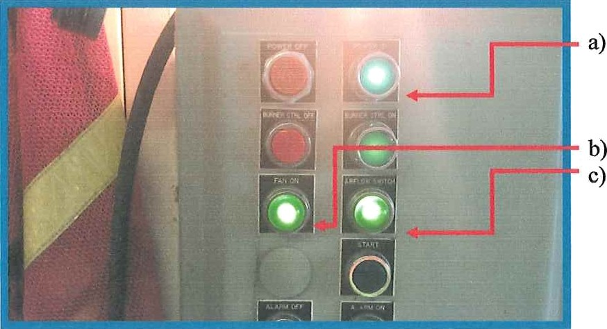
Fuel system relay energized indicator

“Fan On” indicator “Airflow Switch” energized indicator

  - Burner Start-up — Energize and Set Modulating Valve
    - Set Modulating Valve Mode and Position
      - The Modulating Yalve adjusts the amount of gas admitted to the burner and therefore controls the temperate In the drum.
      - The Dryer Flame Control system provides 2 temperature control “modes”; a manual temperature control mode (Manual Mode), and a self-adjusting temperature control mode (Automatic Mode).
      - The Flame Control System will initiate burner operation with the Flame Temperature Conti'ol set in the Manual Mode of operation.
      - Set the initial opening position of the Modulating Valve according to the “Start- Up Settings” chart in the plant operating procedures to assure safe Light O@and safe drum warm up.
      - The drum dryer is typically allowed to initially operate in Manual Mode to gently warm up the drum prior to admittñig product, which takes from 5 to 10 minutes.
      - Monitor the Output Tempet'ature to assure safe drum temperatures are not exceeded.
      - The drum dryer is then typically operated in the Manual Mode with product flowing to establish near steady state conditions.
      - Change to Automalf'H Code in accordance with plant operating procedures.

bazoiog:
The heat input from the burner must be limited when product is not flowing through the drum to prevent dust fires and damage to the drum from overheating. It is also desirable to warm up the drum gradually to reduce stresses on the equipment.

... ..‹ ›. ,

  - Burner Start-up - Inspect And Set Equipment

Inspect The Burner And Burner Barrel
      - Visually inspect the burner and burner barrel for personnel safety, damaged or out of place components, foreign objects (such as tools), broken or missing refractory lining, etc.

View: Area to inspect prior to and immediately after initiating flame

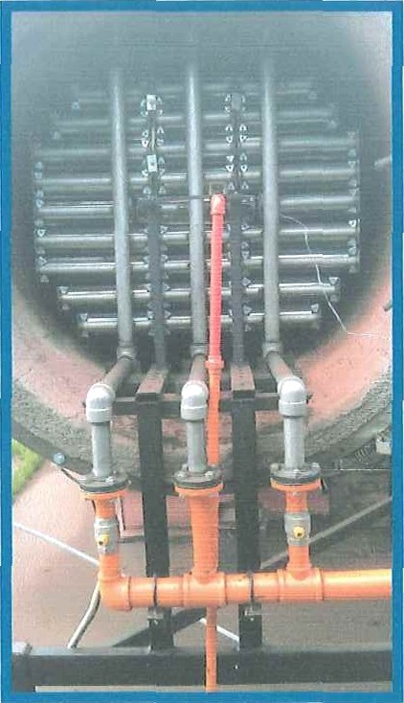

Check Isolation Valves
The burner is composed of 3 manifolds of burner elements.
      - The center manifold of burner elements is operated for all drying situations.
      - The left and right manifolds of burner elements can be turned on or off independently by fully opening or fully closing the Isolation Yalve situated on each.
      - For burner testing purposes, one or both of the left and right manifolds of burner elements can be turned off to reduce the amount of energy input while still providing stable temperature control when in the self-controlling (automatic) temperature control mode.
      - Assure the Isolation Valve are either fully open or fully closed before burner ignition. Do not operate the burner with a partially open isolation valve.
Do not operate the burner with a partially open Isolation Valve. A partially open Isolation Valve could cause improper ignition and stability of the flame, resulting in an unsafe and inefficient operating condition.

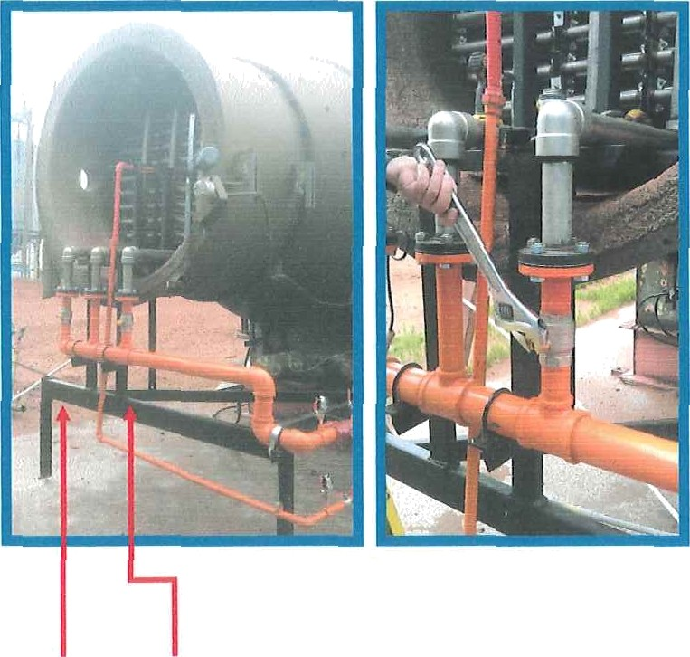
a) Left and right Isolation Valves
View: Isolation Valves with the right valve being operated

  - Burner Start-up - Initiate Flame And Manage Product Drying

    - Ignite Burner (Light Off}
      - Initiate dryer burner operation by momentarily pressing the “Start” button on the
Flame Control Panel.
        - The automatic controls will conduct a series of self-tests, initiate the pilot flame, and then initiate main burner operation.
        - This “fire up sequence” takes about 60 seconds.
      - Immediately after ignition, observe flame and turn off flame controls if full and stable flame is not established across all engaged burner elements,

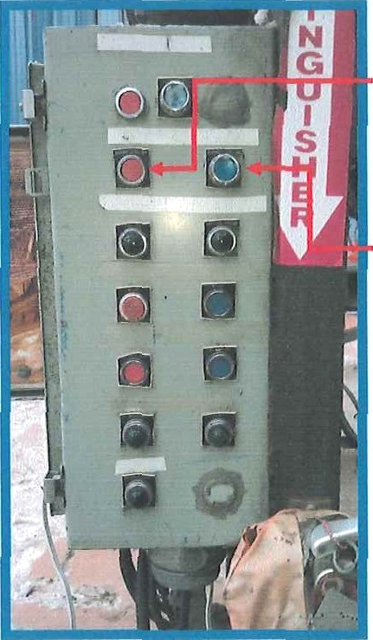
View: Burner Control Panel

Components:
- Burner “Stop” switch

- Burner “Start” switch

    - Monitor Warm Up Temperature And Initiate Product Flow
      - Monitor the dryer temperature and conform to the /'fnnf Operating Pt oceJut’es
which may include:
        - Allow the drum to warm up in the Manual Mode.
        - Adjust the Modulating Valve opening as necessary to maintain the appropriate warm up heat input and temperature.
        - Initiate product flow through the dryer.
        - Increase the Modulating Valve opening in Manual Mode to establish near steady state conditions at the desired dtying temperature with product flowing through the dryer.

    - Establish And Monitor Desired Output Product I¥toisture Content
      - Monitor the dryer temperature and conform to the Plant Operating Procedures
which may include:
        - Set the temperature control to the desired drying temperature for the type of product being dried according to the Start-Up Senings Chart.
        - Switch to the Automatic Operating Mode.
        - Monitor the dryer product output temperature and moisture content and adjust the input feed rate and/or drying temperature in accordance with Plant Operating Pi'ocedures.
Operation at excessive drum temperatures, operation at high temperatures for excessive periods, or over-drying product, could result in a fire within the dryer and subsequent damage to equipment.

  - Burner Staged Shut-Down
The shut-down of the burner and drum dryer coordinates the cessation of product flow and the extinguishing of the flame.
Warning:
Continued operation at high heat energy input by the flame control system without the flow of cool, high moisture product into the dryer, will quickly cause over-heating of the dryer and damage to components.

- Cease the input of product into the dryer in accordance with Plant Operating Procedures.
- Within moments of ceasing product input, press the “Stop” switch to turn off die
flame control system.

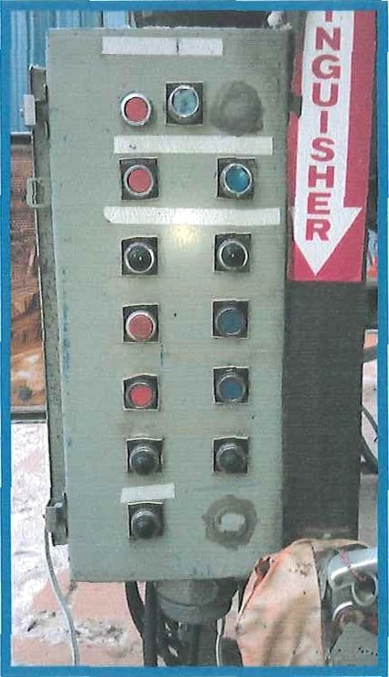
View: Dryer Control Panel

  - Burner Emergency Shut-Down
“Emergency Stop” switches are located at 3 locations around the plant. Pressing any of these switches will safely extinguish the flame. However, the drum, blower and other components may need to be restarted in accordance with the to Plant OperatfHff Procedures assure no damage from over-heated components or product.

2 Section 2 - Maintenance And Components
All fuel control system maintenance to be conducted by suitably certified persons.

F C I

1.1 General Components Layout

Following are a series of figures and diagrams that illustrate the drying installation. Please refer to the text in the body of this manual for a full description of these figures and diagrams.
    - Figure - Plant Control Panel
View: Plant Control Panel

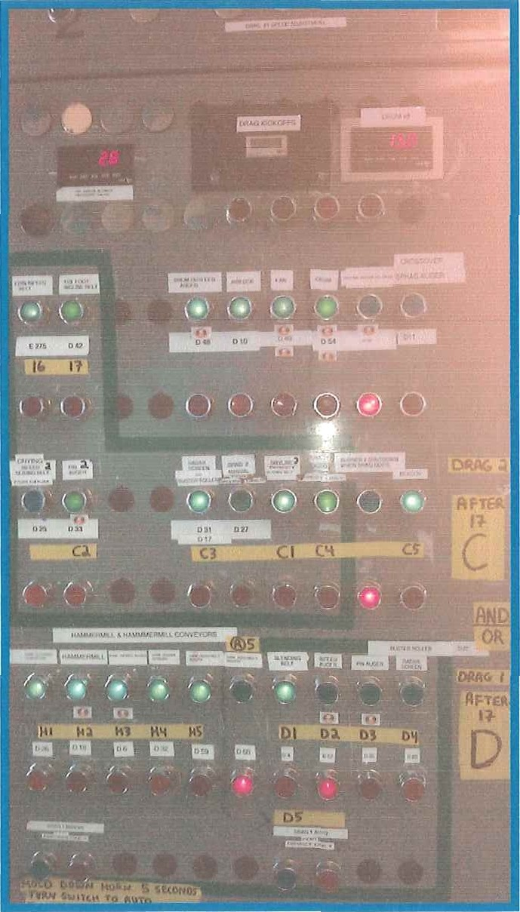

    - Figure — Fuel Train Components General Layout

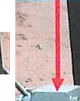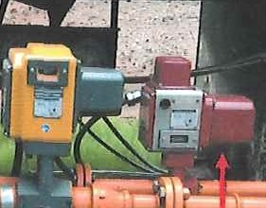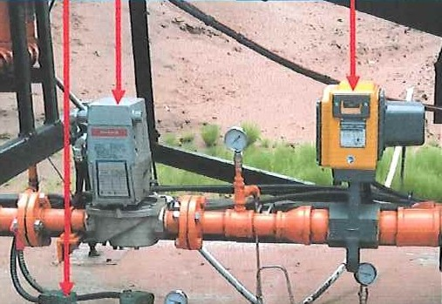View: Fuel Train

Figure — Firing Valves

View: Firing Valves CLOSED Position

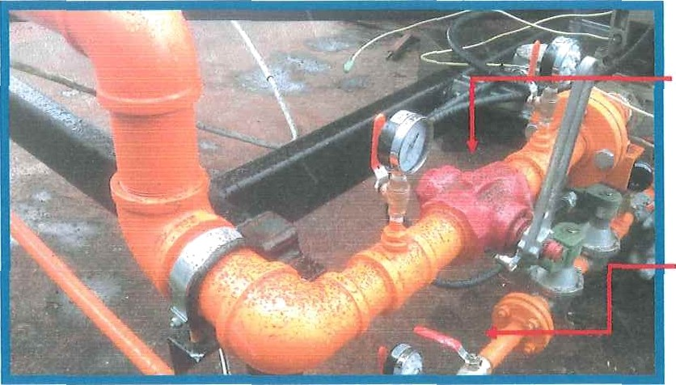
Components:

      - Main burner firing valve

      - Pilot burner firing valve

    - Figure - lgniter

View: Pilot with igniter and high tension lead installed

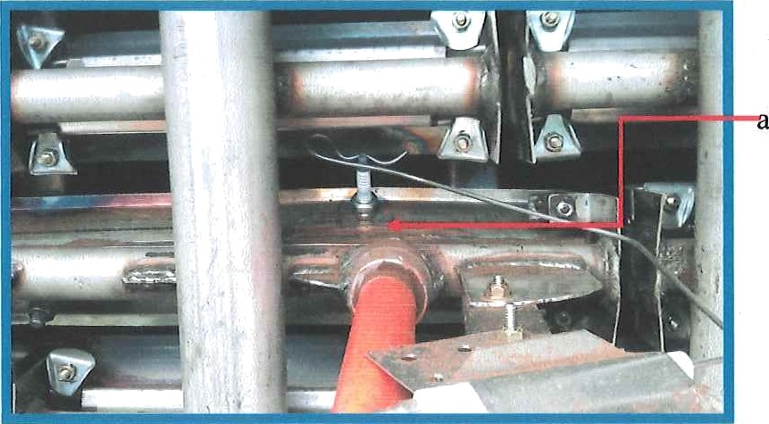
Components:

) Ignites

    - Figure — Flame Control Electronics

View: Flame Control Panel
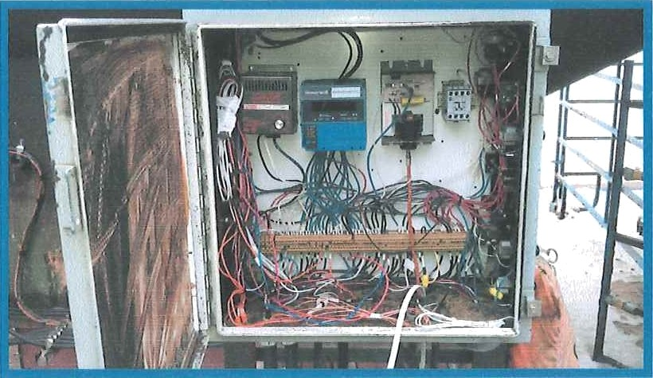

    - Figure — Airflow and Temperature Sensors
The system incorporates 2 proof of combustion air switches. One is an approved switch. Although the other is NOT an approved switch, it can only fail in a safe mode that does not detract from the effectiveness of the approved switch. The unapproved “sail” switch has served in this function for many years and does not reduce safety.

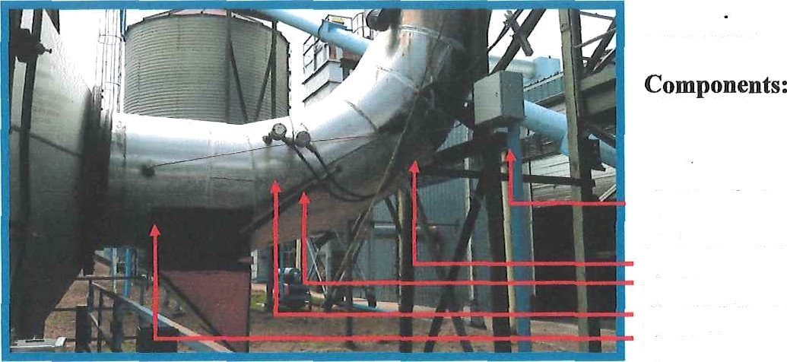
View: Drum discharge connection

      - Proof of combustion air pressure switch
      - Sail switch
      - Temperature sensor
      - High limit sensor
      - Pressure sensor

Safety, Maintenance & Gperat:ions Checklists
A series of checklists are provided on the following pages. The checklists are to be updated on a regular basis as plant and machine conditions require.

    - Startup Checklist

Safety, Maintenance & Operation Checklist

Prior to Each Flame Startup - Confirm That

Safety
    - Assure Emergency Preparedness.
    - Coordinate Drying Activities.
    - Assure Personnel Are Adequately Trained And Equipped.
    - Clear Equipment Of Personnel And Foreign Objects.

Equipment
    - Open Master Gas Supply Valve At Gas Shack
    - Open Appliance Gas Valve
    - Open Manual Firing Valves
    - Engage Product Conveyors, Drum and Fan

    - Daily Checklist

Safety, Maintenance & Operation Checklist

Daily - Confirm That

Equipment
Any recent maintenance or repair activity did not leave the equipment in an unsafe condition, with access panels closed, etc.

Maintenance
Dryer and fuel control components are in good condition and not damaged, such as by impact from a forklift truck, etc.
The entire system, including outdoor areas, has a "walk around" while operating to observe any abnormal: flame condition, noise, odor, gearbox temperature, bearing temperature, belt slippage, vibration, etc.

    - Weekly Checklist

Safety, Maintenance & Operation Checklist

Weekly - confirm That

Maintenance
W53 Air inlet area is clean and free from obstructions and debris.
¥if54 Vent stack rain caps function properly.

    - Monthly Checklist

Safety, Maintenance & Operation Checklist

Monthly - confirm that:

Safety
All staff are aware of changes to the operating or emergency procedures that impact them.
Confirm high temperature limit switch is set and operates properly.
Combustion air pressure switch is set and operates properly.
UV scanner and flame controls operate properly to extinguish flame within 4 seconds of loss of observing flame.

Operation
Operating manual, checklists and procedures are current and include any revisions required due to equipment or other changes.
All staff are aware of any revisions made to this Operator's Manual or plant operation, maintenance and Emergency Response procedures.
All new staff are aware of dryer training requirements and Emergency Response Plan.

F C I

    - Annually or After Alterations

Annually or after machine alterations
confirm that:
In addition to all daily, weekly and monthly service schedules, and in addition to confirmation of compliance with CSA B149.3-10:

Safety
Operating and emergency response procedures are reviewed, updated, and practiced.
A staff training refresher course is conducted to include updates to the manuals and emergency procedures.
A thorough inspection is conducted to assure compliance with CSA B149-10.

Equipment
Dryer, refractory and flame control iitel train components are inspected for cracks, wear, or evidence of deterioration.

  - Fuel System Diagrams And Components
    - Fuel Train Component Identification Key
Item identification key refers to component listed in the next section. Components:

      - 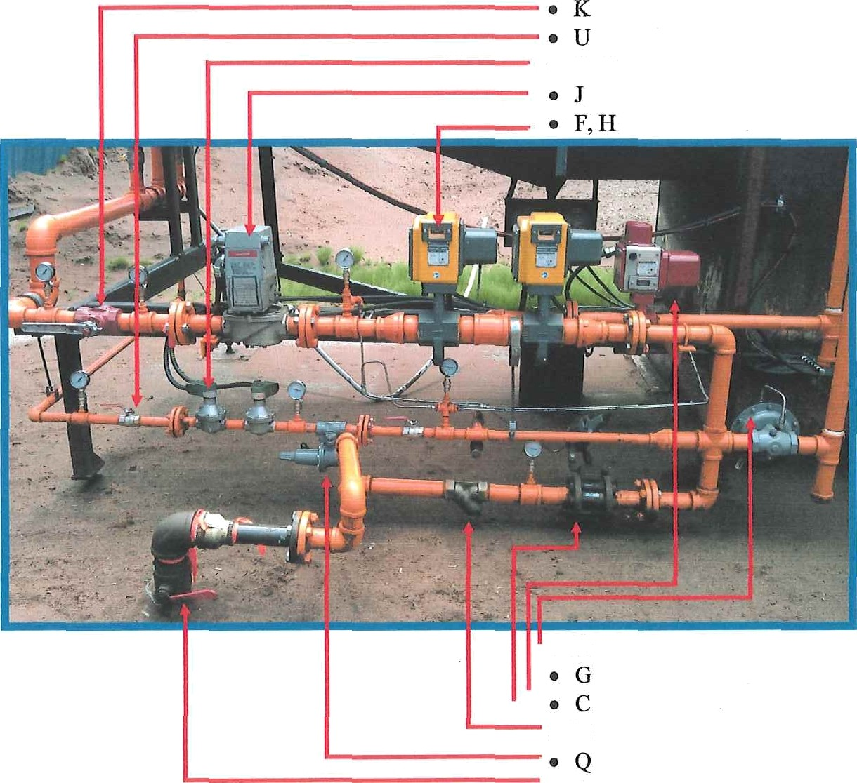A
- D
- B

    - Gas Train Schematic
Fuel train — CSA B149.3-10, 5.3.2, 5.3.6, 5.3.11
(as per CSA Figure B.3)

Item identification key refers to component listed in the next section.

Are satire lest V ••
M VaTvo , d I ag no s I u To ol ation tost

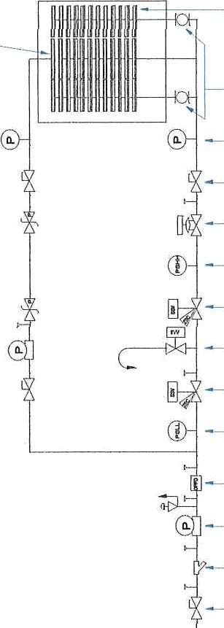
L F russu ro ios t point

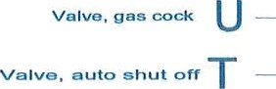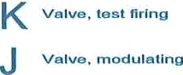
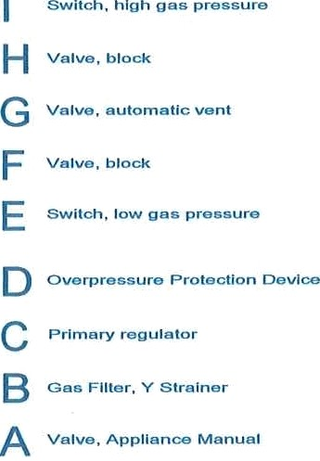
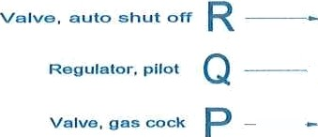

  - V\/iring Diagrams And Components
    - Wiring Diagrams
Wiring diagrams are stored under separate cover.

    - Description of Electrical Components
The itemized list of flame control electrical components refers to the following diagram.

Item identification key refer‘s to component listed in the next section.

l‹ :

‹ ' ' ' '

Electrical Components List

Dwg. Ident | Part or  Assembly | SGV2 Design - Component  Material / Associated Drawing / Description, Note, or Comiiicnt Recommendation / Alternatives
CEPF | Cabinet  Electrical Panel | CSA approved NEMA 3 or 4 Electrical Cabinet of a size  suitable to hold all the components,
FCRJ | Burner Control  (primary flame control telay) | Honeywell Burner Control RM7388B  (plus required modules and jumpers clipped to provide 30 sec purge, 4 sec TFI, interrupted pilot ignition, lock out on flame failure.
FCRI/05 | Flame monitor | Honeywell flame scanner C7012E F rectification detector,  self-checking
ICI | Ignition cable | 7mm Silicon Tiger Tails by Standard Motor Products  (8mm optional) or equivalent  Alternate: UAP P/N 734706, Norwest P/N BLWCC7L
IEl | Igniter  Electrode | Spark Plug NOK DR8ES-L or equivelent
SGl | High voltage  ignition transformer | Honeywell Q624A10I4, (preferred due to spark timing),  6000V+ secondary
SHTA01- | High  temperature over limit switch  (plus required accessories) | Honeywell UDC2000 Universal Digital Conboller/Limit  Control, Model DC200H-0-000-1C000-0, S/N 955  00181207001, configured for manual reset, plus associated thermocouple, immersion well, leads, etc
SSP I | Switch, Static  Pressure - Proof of combustion air | CSA certified Johnson Controls differential air pressure  switch model P32AC-2C, Sensitive Pressure Switch, Code No. UT-1927195, Issued February 1, 2009, Switch accommodates 0.05” WC to 5” WC with 1 psig over- pressure
TR1 | Transformer | AT72D1725, Transformer 110/24a 40va Multi-MT,

F C I

2.6.3 Description of Gas Components
Note: This table is updated from the initial documentation. Refer to fuel train components diagram in Appendix 6.1.

Dwg. Ident | Part or Assembly | SGV2 — Component, Material, Comment,  Altei-natives
.A | Appliance isolation  hand valve | CSA labeled 600 WOG Lubricated Ball Valve, 1/4 turn,  3" npt, handle to be arranged to be in line with flow when in open position
.B  .c | Gas filter, Y strainer | 2” CSA approved Y Strainer, 150 psi body
 | Primary appliance  regulator | Sensus Regulator, Model 243RPC-B, 2”, 3/” orifice,  Brown spring 10-35 psi control range, Max. Inlet 150 psi, G-0115 s/n 18405928, Installed 2014 to replace original, found leaking, Singer, American Meter Div., Model 02H 71 CS174, c/w 70643 spring module
.D | OPD Overpressure  Protection Device | Fisher 1808 Pilot Operated Relief Valve, 2”NPT, 3-18  psig adjustable output spring, set 15 psi. Straight body design.
.E | Safety cut off switch,  low gas pressure | Dwyer Mercoid Series DR-221-5S (2-60 psi) Pressure  Control, manual reset, (set 3 psi decreasing)  - http://www.pollardwater.com/pdf/pdf web manuals/ DwyerMercoid dmb.pdf
.F | High Pressure Fast  Acting Shut Off valve | Maxon 300CMAI1-AA12-BB23A0 Shut off valve, (see  also .H)
.G | Valve, automatic vent,  main | Maxon I 50MA21-AAI2-BBI3A0 Vent valve
.H | High Pressure Fast  Acting Shut Off valve | Maxon 300CMA11-AA12-BB23A0 Shut off valve, (see  also .F)
.I | Safety cut off switch,  high gas pressure | Dwyer Mercoid Series DR-221-SS (2-60 psi) Pressure  Control, manual reset, (set 15 psi increasing) (see also E)
.J | Valve, modulating | Honeywell Type V9055A 1055 Fluid Power Gas Valve,  c/w 5055B valve body, max close off 15 psi, CSA File

